Portraits of Groups II,
Orientation Reversing Actions

Jay Zimmerman
Mathematics Department
Towson University
8000 York Road
Towson, MD 21252, USA
E-mail: jzimmerman@towson.edu

1. Abstract

This paper looks at the question of representing small finite groups as groups of transformations of a compact surface of genus two or more. Transformations which reverse the orientation of the surface are allowed. In particular, we will draw the portrait of a group of order 48 with symmetric genus 2 which is the image of a hybrid triangle group with orientation reversing elements.

2. Introduction

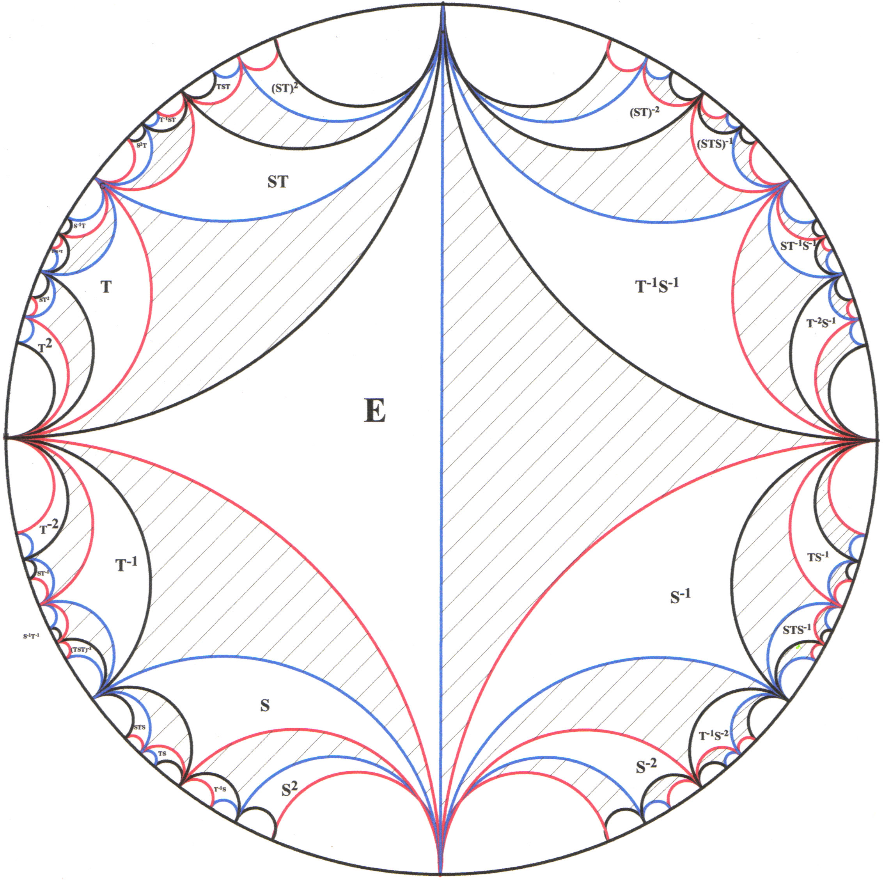
The first portrait of a group was given in Burnside [1]. Burnside constructed a portrait of the cyclic group with n elements and the free group, F_{n}, on n generators in the Euclidean plane. More precisely, since the one to one plane transformations that Burnside used were inversions in a circle, they should be thought of as transformations of the Riemann sphere. The relationship between the circles used determines the resulting group. The construction of the free group, F₂, can be most easily drawn in the hyperbolic plane (see Burnside [1], page 379). Burnside began with a single region associated with the identity transformation, E. Since inversion in a circle reverses the orientation of the plane, Burnside used a composition of two inversions for each element of the free group. The region E is colored white and the region obtained by a single inversion is colored black. Therefore, a fundamental region for the group of transformations is the union of one white and one black region. Each white region (and its associated black region) is labeled with the element of the free group that transforms the fundamental region into that region.
Figure 1 is a portrait of this two generator free group constructed by Geometer's SketchPad. Each 'triangle' is bounded by arcs colored red, blue or black in our sketch. Inversion takes a shaded region into a non-shaded region and vice versa. Therefore, each group action is represented by the composite of two such inversions. We interpret this picture as a portrait of a group with presentation 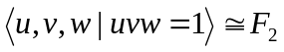.
Now suppose that we have a finite group, G, generated by 2 generators. Thus, the elements u, v and uv have finite orders, say , m, and n. This group is the image of the free group by a normal subgroup, N. After associating an element of F₂ to each region, the final step is to identify all regions with labels from the same coset of N. After this identification, the finite group, G, is represented as Figure 1 - Portrait of a Free Group [5]
a group of transformations on a surface of some genus. The finite
group G is the quotient of a Triangle group, 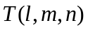 with presentation 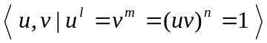. This is an orientation preserving action. Burnside (see [1], page 396) drew a portrait of the quaternion group of order 8 on a surface of genus 2. The paper, Portraits of Groups [5] drew a portrait of the dicyclic group of order 12 on a surface of genus 2 and a portrait of the quasiabelian group of order 16 on a surface of genus 3.

3. Non-Orientable Actions

Suppose that a finite group G acts on a surface in such a way that some of the elements reverse the orientation of the surface. In this case, half of the elements will reverse the orientation and half will preserve it. The half that preserve the orientation form a subgroup, denoted G⁺ with the orientation reversing elements as its coset. The group G⁺ is always the image of a Fuchsian group and triangle groups are a type of Fuchsian group.
There are two possible groups with a specific triangle group as their orientation preserving subgroup [3]. The group with presentation is called the Full Triangle Group, denoted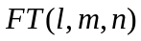. The triangle group is clearly the subgroup 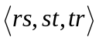 of the full triangle group. Any triangle group is a subgroup of a full triangle group. Many finite groups occur as the quotient of a full triangle group where the involutions are reflections. These groups contain elements that have orientation reversing action on the surface.
The portraits of groups given in [1] and [5] are really portraits of a quotient of a full triangle group where the black regions should be labeled with the orientation reversing elements. Therefore, these portraits can be thought of as portraits of extensions of degree 2 of the orientation preserving subgroups, namely the quaternion group of order 8, the dicyclic group of order 12 and the quasiabelian group of order 16. That is why we need the fundamental region of the orientation preserving group of transformations to be one white and one black region combined. It follows that we already know how to draw a portrait of any quotient of a full triangle group.
A group with presentation 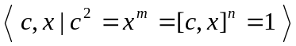 is called a Hybrid Triangle Group and is denoted by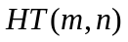. The orientation preserving subgroup of is 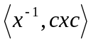 and this subgroup is isomorphic to the triangle group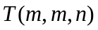. This is the second possible group with a specific triangle group as its orientation preserving subgroup. The purpose of this paper is to draw a portrait of a group of symmetric genus 2, where the group is a quotient of a hybrid triangle group and hence has orientation reversing elements.
A hybrid triangle group, is a subgroup of the full triangle group 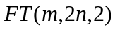 ( [2], page 39). Let and 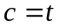 in the full triangle group. It is easy to see that 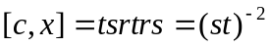, since 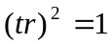 implies that these elements commute. Therefore, the subgroup 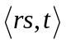 satisfies the relations of . Thus our drawing of any finite quotient of will be as a subgroup of .
In representing in a diagram, the generator r is inversion in a blue curve, s is inversion in a black curve and t is inversion in a red curve. Properly, all of the inversions should be reflections in "lines" in hyperbolic space and the surface is a quotient of hyperbolic space. However, the important property is the relationship between the triangles and so we will distort the triangles so that they fit into a polygonal region in the plane. This has the advantage that the triangles do not become microscopically small as they get near the boundary of the polygonal region. The polygonal region for the group P₄₈ is given in Figure 2.
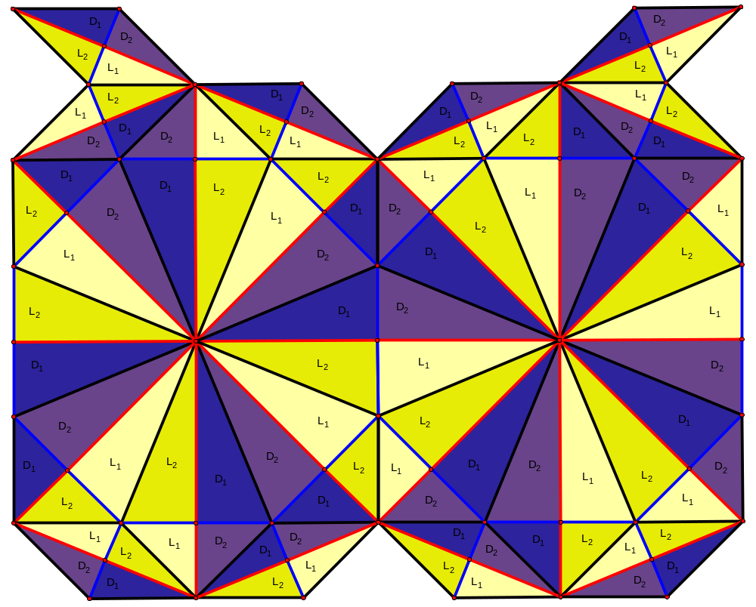

Figure 2 – Polygonal representation of P₄₈

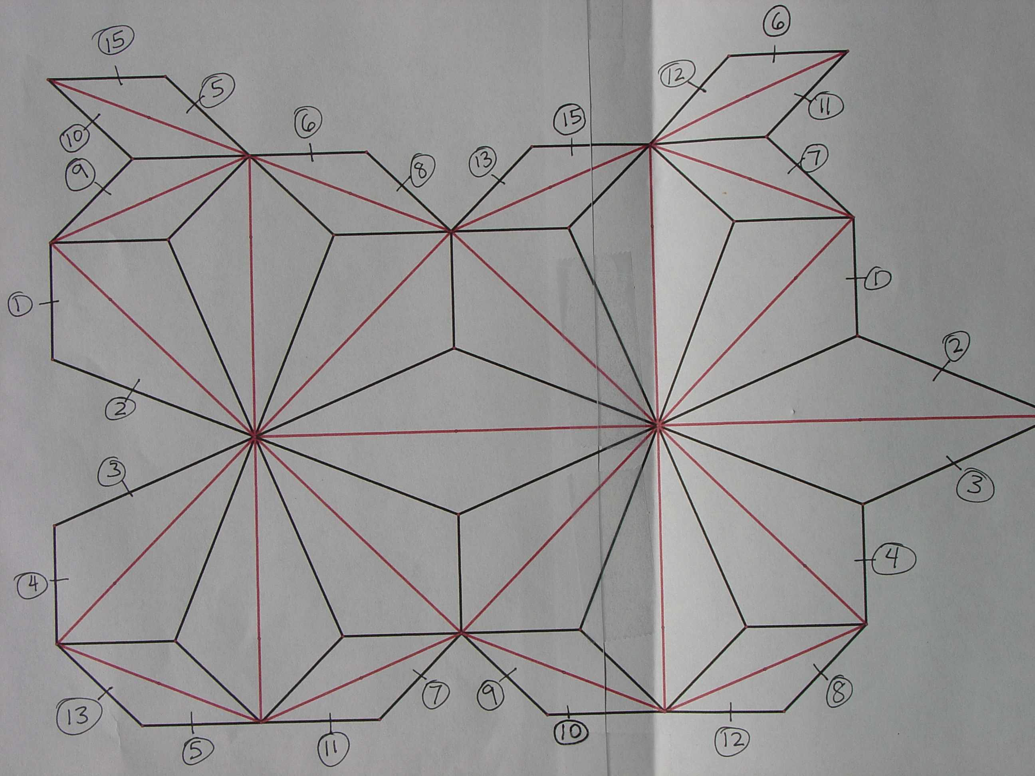
The diagram in figure 2 is part of the diagram for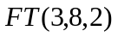. Regions labeled L₁ (pale yellow) and D₁ (blue) have the same orientation as the fundamental region and regions labeled L₂ (darker yellow) and D₂ (purple) have the opposite orientation from the fundamental region, under the action of. The fundamental region for the action of the elements of 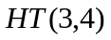 is the union of the regions L₁ (pale yellow) and L₂ (darker yellow) just below the center of figure 2. We label each region in the diagram for by the element of that transforms the fundamental region (labeled with the identity) into the target region. There are two types of images of this fundamental region, depending on whether the orientation of the image is the same as the orientation of the fundamental region or whether Figure 3 - Polygon of P₄₈ with connectivity information
the orientation is reversed. Regions with reversed
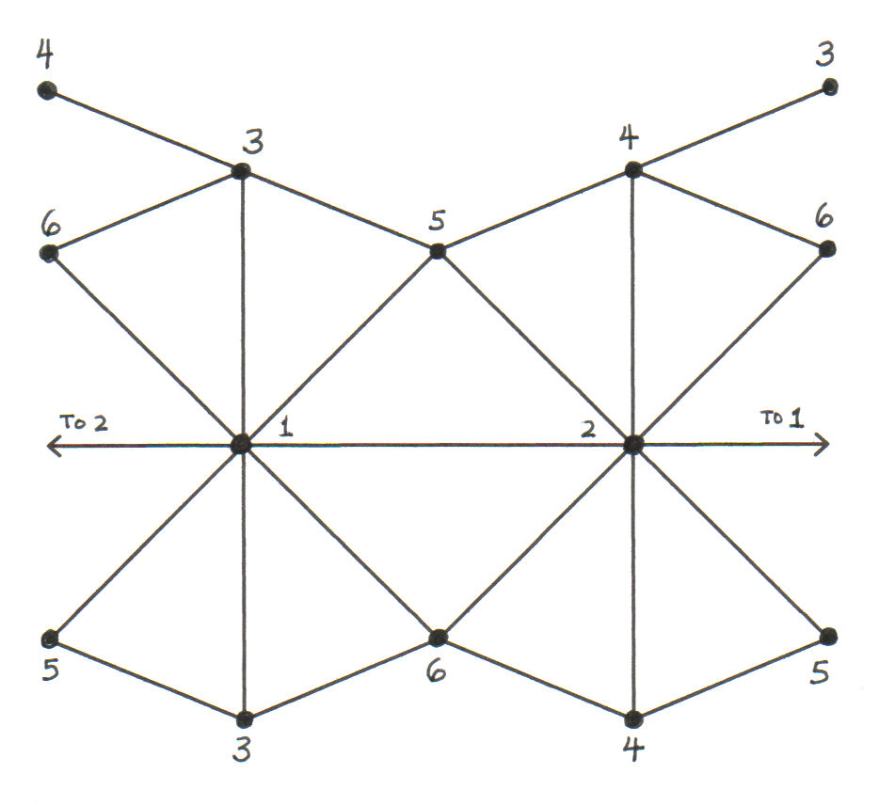
orientation are colored in two darker shades, blue (D₁) and purple(D₂). Thus each region of is colored with either two yellow shades (L) or two blue shades (D). A light fundamental region is transformed into another light region by the composition of a reflection in a blue curve (interchanging pale yellow (L₁) and darker yellow (L₂) first) and then a reflection in a black curve. This corresponds a rotation given by the generator x and it has the same orientation as the fundamental region. A light region is transformed into a dark region with reversed orientation by reflection in a red curve corresponding to the generator c. The portrait really consists of only two types of regions, Light regions and Dark regions. Unfortunately, the generator x moves a light region to an adjacent light region and the same for dark regions. We would not be able to distinguish two adjacent light regions from each other or two adjacent dark regions from each other without the L₁, L₂ and D₁, D₂ distinction. Therefore, we keep the action on the orientation from the original group. Figure 4 - Simplified P₄₈ graph
This gives a portrait with 4 different types of shaded regions.

4. The Group of Symmetric Genus Two

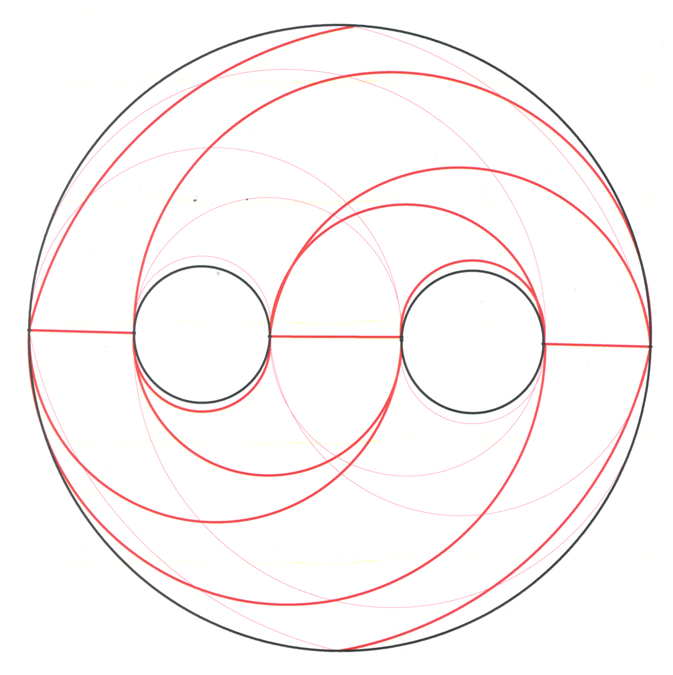
The group P₄₈ has presentation 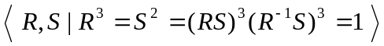. It is a group of order 48 and it is the image of. Therefore, the polygonal diagram in figure 2 is folded on itself. Each edge on the rim is the same as another edge somewhere else on the rim of the diagram. The edges which are identified are given in figure 3. The symmetric genus of P₄₈ is two [4, page 128]. The surface where P₄₈ is drawn is divided up into 96 regions by. The drawing of the group, P₄₈, has 48 faces, 72 edges and 22 vertices. Thus it has Euler characteristic -2 and hence can be drawn on a surface of genus 2. Its 22 vertices are divided up into 6 vertices of degree 16 and 16 vertices of degree 3. Each vertex of degree 16 is connected by two edges to 4 other vertices of degree 16. The remaining 8 edges connect to 8 different vertices of degree 3. Each region of the portrait of P₄₈ is bounded by red and black lines. The blue lines separate each region into two parts for ease of viewing, as explained above. If all of the black
Figure 5 - Genus two surface divided into 16 regions lines inside each "triangle" of red
lines are deleted, you combine 3 faces into one face, delete 3 edges and lose one vertex. The Euler characteristic is unchanged by this operation. If you do this for every "triangle" of red lines in the graph, you obtain a simplified graph with the same Euler characteristic. This graph is shown in Figure 4. Thus the graph consisting only of the red curves can be drawn on the surface of genus two first and then the black curves can be added later. This simplifies the task of drawing this polygon on a genus two surface considerably. This is shown in Figure 5. The bold curves in Figure 5 are the red curves on the front of the genus 2 surface and the thin curves are on the back of the surface. The curves appear to approach each other because they are approaching the sides of the surface. In fact, they approach their intersection at an angle of 45°. We can see this in the close up view of the model P₄₈ on a genus two surface. This picture is displayed as Figure 6.

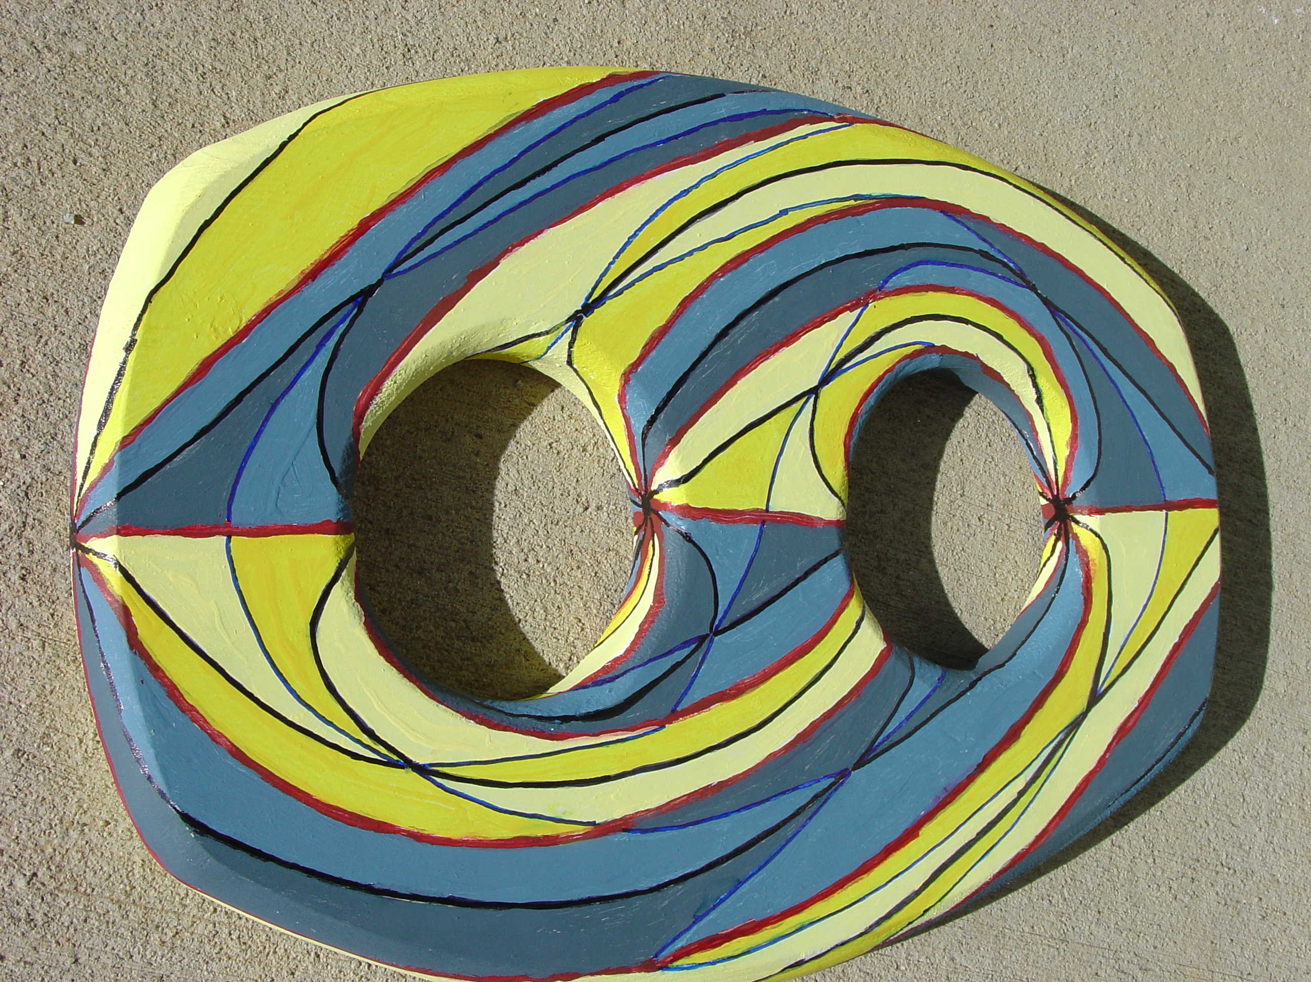

Figure 6 - Portrait of the group P₄₈ with orientation reversing actions.

As we see, the portraits of small groups as a group of transformations with orientation reversing elements give some intriguing and esthetically pleasing drawings. The fact that they cannot be accurately drawn on a plane surface makes them even more interesting.

5. Characteristics of the Simplified Graph

The genus 2 graph obtained by removing all but the red curves has 16 faces, 24 edges and 6 vertices. It is a graph of Euler characteristic -2 and thus cannot be drawn on a surface with genus less than two. Figure 4 illustrates a plane drawing of this graph where all points with the same label are identified. Figure 5 illustrates the drawing of this graph on a genus 2 surface. Figure 6 is the full model with each "triangle" in Figure 5 subdivided into 6 "triangles" with alternating shades of the basic color. Under what circumstances is this simplification of the process of constructing the model possible? Clearly, in this case the element x which gives the group action which permutes the regions inside each "triangle" is an orientation preserving action.
The simplified model is the portrait of the index 2 extension of the quaternion group. As such, it is the same as Burnside's portrait of the quaternion group of order 8. The group P₄₈ does not have a quotient of order 16. It is the semidirect product of a group of order 16 and the cyclic group of order 3. The normal subgroup of order 16 is an extension of the quaternion group of order 8. This subgroup of order 16 is what gives us the simplified model and the orientation preserving subgroup of this group is the group of quaternions. Hence our model in figure 6 is really an elaboration of Burnside's original model of the quaternions acting on a surface of genus 2.

6. Future Research

The next step will be to construct portraits of groups that act on surfaces of genus larger than 2 or 3. It would also be interesting to use group actions where the orientation preserving subgroup is not a triangle group. If the orientation preserving subgroup were a quadrilateral group, then you would expect the fundamental regions to be "quadrilaterals" and the portrait to be significantly different.

7. References

- W. Burnside, Theory of groups of finite order, (Cambridge University Press 1911).
- H.S.M. Coxeter and W. Moser, Generators and relations for discrete groups, 4th Ed., (Springer-Verlag, 1957).
- D. Singerman, On the structure of non-Euclidean crystallographic groups, Proc. Cambridge Philo. Soc. 76 (1974), p. 233 – 240.
- C. May and J. Zimmerman, Groups of small symmetric genus, Glasgow Math. J. 37(1995), p. 115 – 129.
- J. Zimmerman, Portraits of Groups, Conference Proceedings 2006, Bridges: Mathematical Connections in Art, Music and Science, London, England, 131 - 134.

