SHAPES OF MOLECULES

This handout will help you with understanding the shapes of molecules based on their Lewis structure. The shape of a molecule is determined by minimization of the electron clouds that surround a central atom. The atomic orbitals of the central atom have hybridized, with the hybrid orbitals arranging themselves in the shape that minimizes the repulsions of electrons occupying these hybrid orbitals. If you have trouble drawing Lewis structures, please refer to the handout addressing drawing Lewis structures.

We will use the following key to describe the shapes of molecules.
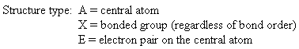
Groups: sum of X and E (number bonded groups and electron pairs)
Hybridization: which atomic orbitals were mixed
Electronic geometry: shape based on regions of electron density
Molecular geometry: shape based on location of nuclei
Bond angle: angle between X-A-X (central atom and two bonded groups)

We will look at each structure type in turn. An example of each will be given.
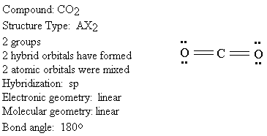

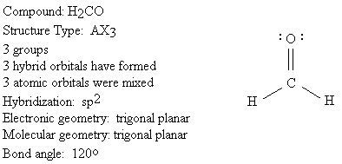
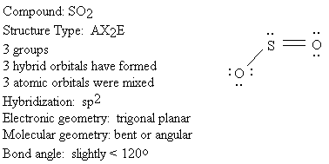

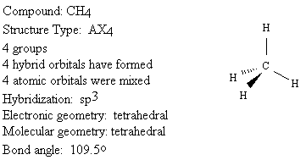

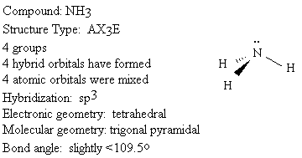

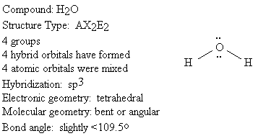
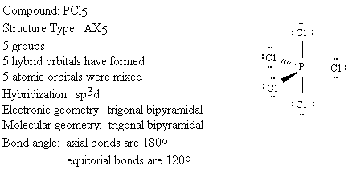

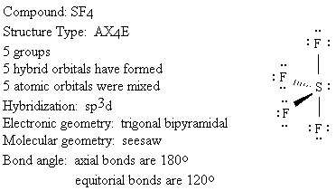
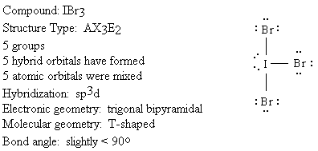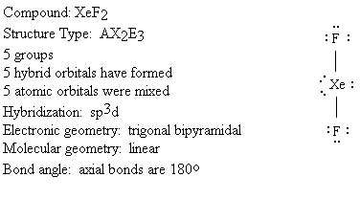
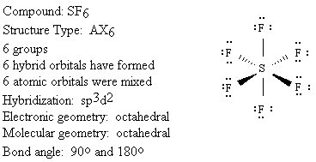

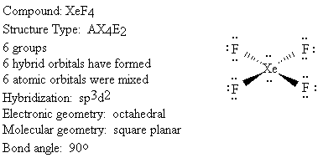
© Copyright, 2001, L. Ladon. Permission is granted to use and duplicate these materials for non-profit educational use, under the following conditions: No changes or modifications will be made without written permission from the author. Copyright registration marks and author acknowledgement must be retained intact.

