**Steps to Download Visual Studio C++ Express from Dreamspark.com**

1. Go to URL: <https://www.dreamspark.com/Student/Default.aspx>

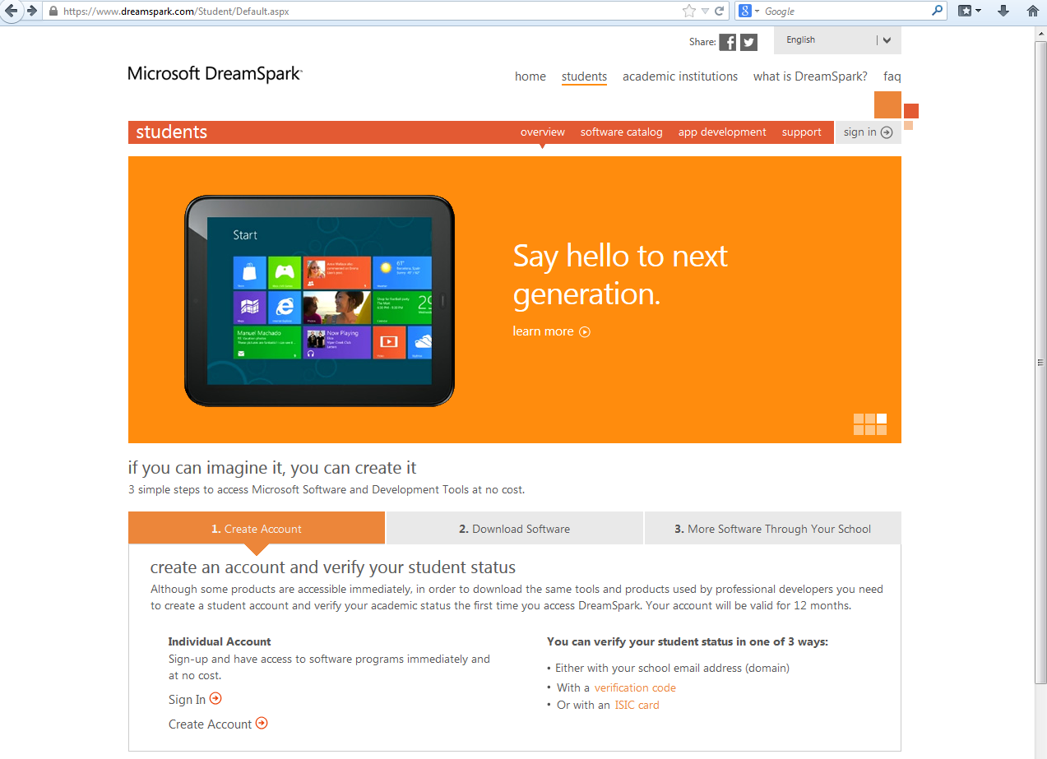

1. Click on “create account”.
2. Create account with school email and your own password.
3. Verify student status via ‘School’ email
4. Check your school email and you will see an email with subject” [Microsoft Academic Verification] Confirming Your Academic Status”
5. Click on the link in the email to activate your account. You would see a page like below after successful activation of the account:

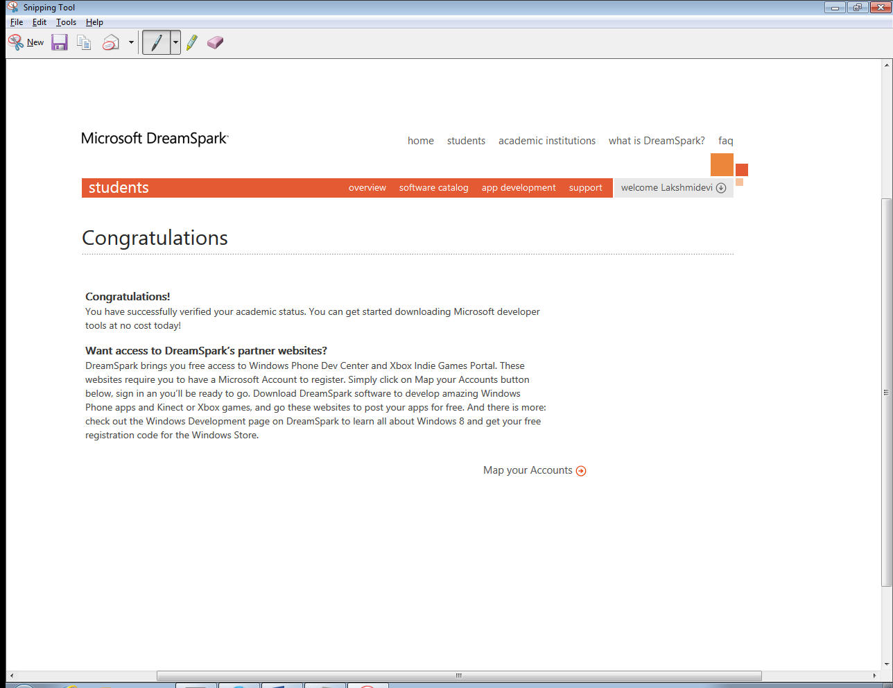

1. Click on “software catalog”.
2. Click on “Visual Studio Express 2013 Preview for Windows Desktop” under “Developer & Designer Tools”. You will see screen like below:

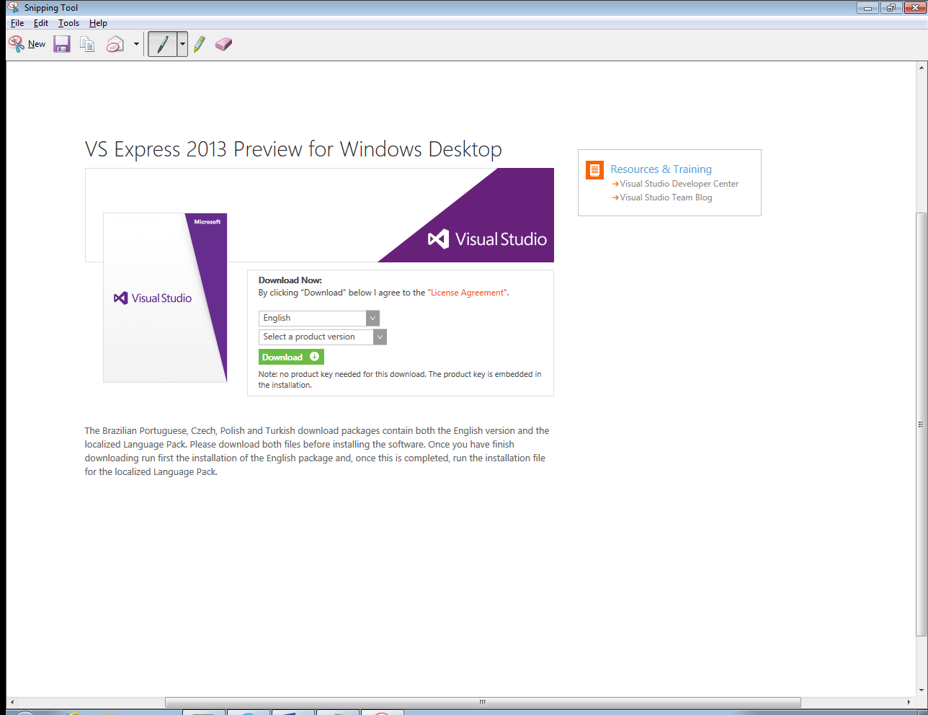

1. Click next to “Select a product version” and select “32 bit” from drop down menu
2. Click on “Download” green icon.
3. If you are using Mozilla firefox browser, you will see pop-up window. 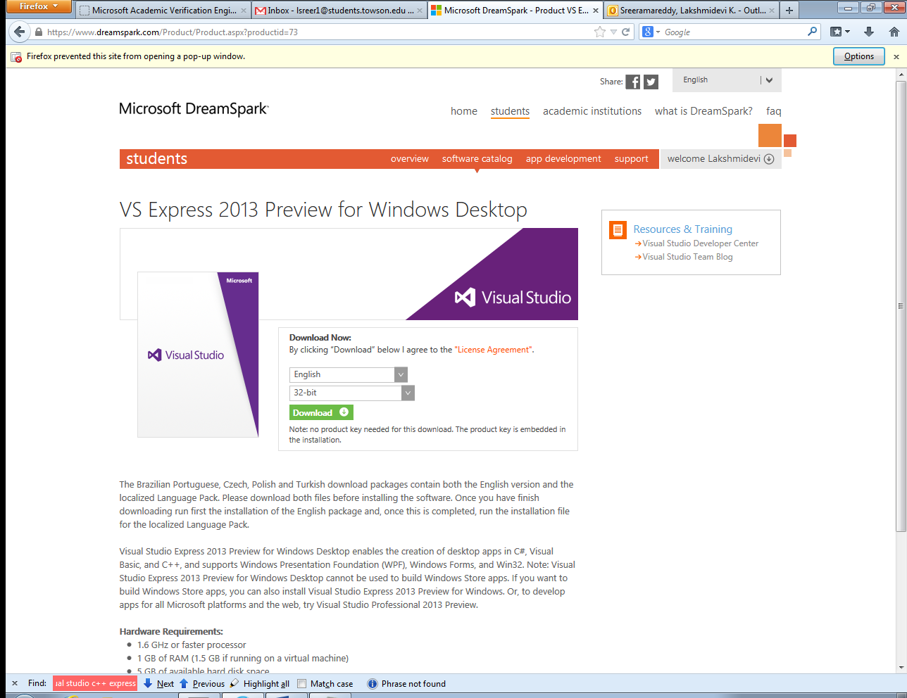
4. Click on “options” and click “Allow pop ups”.
5. Click on “Download” again on the same page.
6. You will see following page
7. 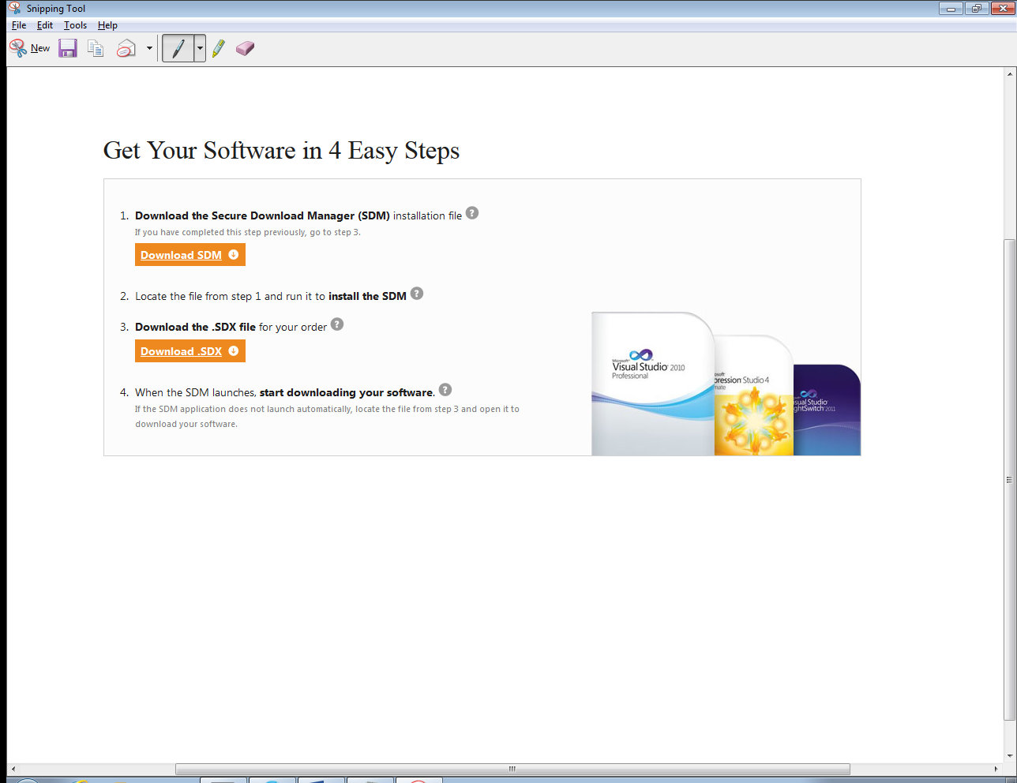
8. Follow steps 1 through 4 in the above page.
9. You will get an .iso file.
10. You can either burn to a DVD or use “7 zip” to extract the downloaded .iso file and double click on .exe file to install.